# Certificate

**This is to certify that Informatics Project on   
Connect 4(Multiplayer Turn-based Brain Game) has been completed by Nisarg Kolhe, Mehul Rai, Akshat Trivedi and Ashish Wadhwani under my supervision and guidance in the session 2014-2015.**

**I certify that project report is up to my expectations and as per the guidelines issued by C.B.S.E.**

**Mr. Anurag Sehgal**

**H.O.D. Computer Science**

# Acknowledgement

**In journey of exploring knowledge in the field of Informatics Practices, while doing our project we felt indebted towards our IP teacher, Mr. Anurag Sehgal, as this project wouldn’t have been complete without his thought evoking guidance.**

**We extend our sincere gratitude towards   
Mr. Ajay K. Sharma, Principal, Delhi Public School Bhopal for his constant encouragement.**

**We are also thankful to our parents for understanding and supporting us and providing us with valuable suggestions.**

# Frame 1: Splash.java

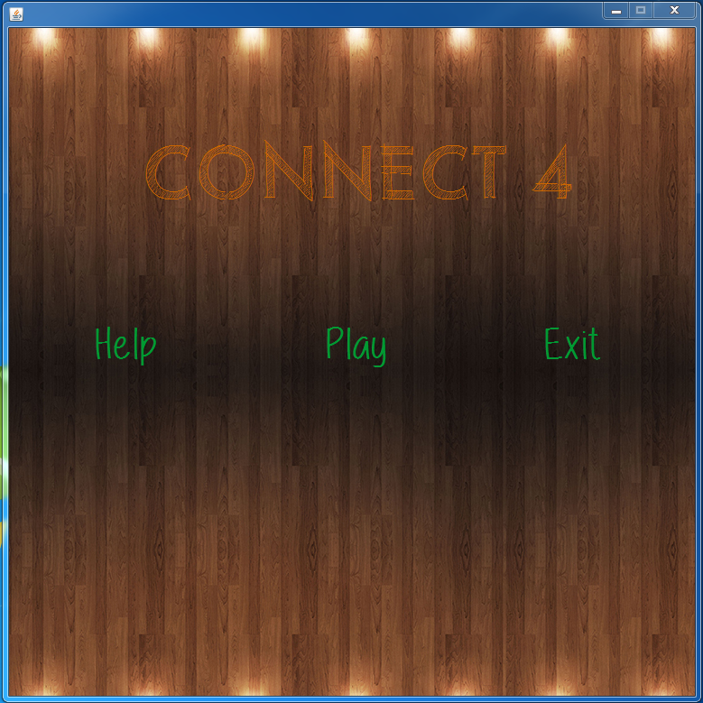  
Overview

* This is the first frame in the project and acts as the ‘home page’ for the project.
* It provides links to ‘About’ section for rules and information on the game, ‘Play’ to start the game and ‘Exit’ to terminate the game.

# Splash.java

1. **public** **class** Splash **extends** javax.swing.JFrame {
3. /**
4. * Creates new form NewJFrame
5. */
6. **public** Splash() {
7. initComponents();
8. }
9. **private** **void** cmdsetActionPerformed(java.awt.event.ActionEvent evt) {
10. **new** About().setVisible(**true**);
11. **this**.dispose();
12. }
14. **private** **void** cmdexitActionPerformed(java.awt.event.ActionEvent evt) {
15. System.exit(0);
16. }
18. **private** **void** jButton1ActionPerformed(java.awt.event.ActionEvent evt) {
19. **new** VS_Player().setVisible(**true**);
20. **this**.dispose();
21. }
23. **public** **static** **void** main(String args[]) {
24. java.awt.EventQueue.invokeLater(**new** Runnable() {
26. **public** **void** run() {
27. **new** Splash().setVisible(**true**);
28. }
29. });
30. }
31. // Variables declaration - do not modify
32. **private** javax.swing.JButton cmdexit;
33. **private** javax.swing.JButton cmdset;
34. **private** javax.swing.JButton jButton1;
35. **private** javax.swing.JLabel jLabel1;
36. **private** javax.swing.JLabel lblBg;
37. // End of variables declaration
38. }

# Frame 2: About.java

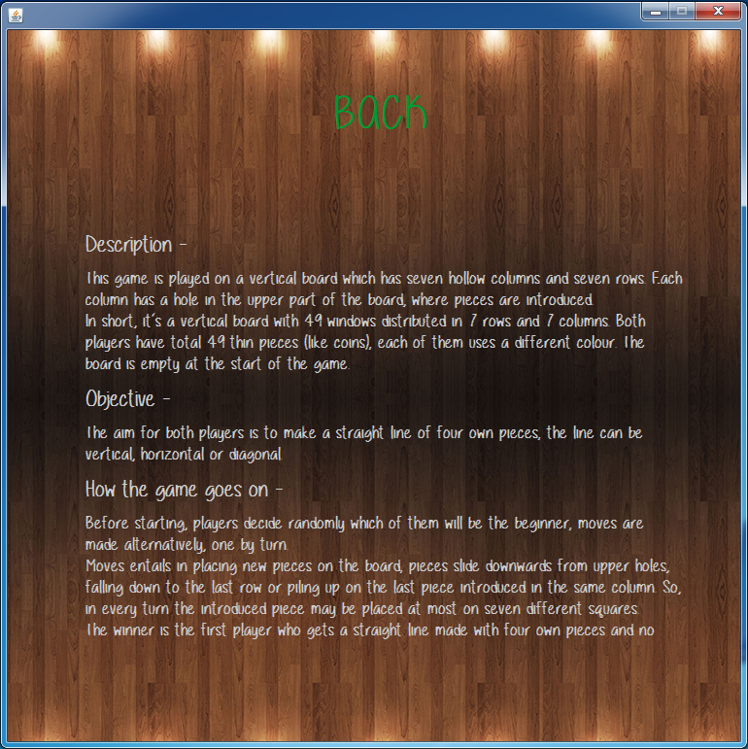

Overview

* It provides description and objective of the game.
* It also provides how the game works and how it is meant to be played.

# About.java

1. **public** **class** About **extends** javax.swing.JFrame {
3. /**
4. * Creates new form Help
5. */
6. **public** About() {
7. initComponents();
8. }
9. **private** **void** jButton1ActionPerformed(java.awt.event.ActionEvent evt) {
10. // TODO add your handling code here:
11. **new** Splash().setVisible(**true**);
12. **this**.dispose();
13. }
15. **public** **static** **void** main(String args[]) {
16. /* Create and display the form */
17. java.awt.EventQueue.invokeLater(**new** Runnable() {
18. **public** **void** run() {
19. **new** About().setVisible(**true**);
20. }
21. });
22. }
24. // Variables declaration - do not modify
25. **private** javax.swing.JButton btBack;
26. **private** javax.swing.JLabel lblAbout;
27. **private** javax.swing.JLabel lblbg;
28. // End of variables declaration
29. }

# Frame 3: VS_Player.java

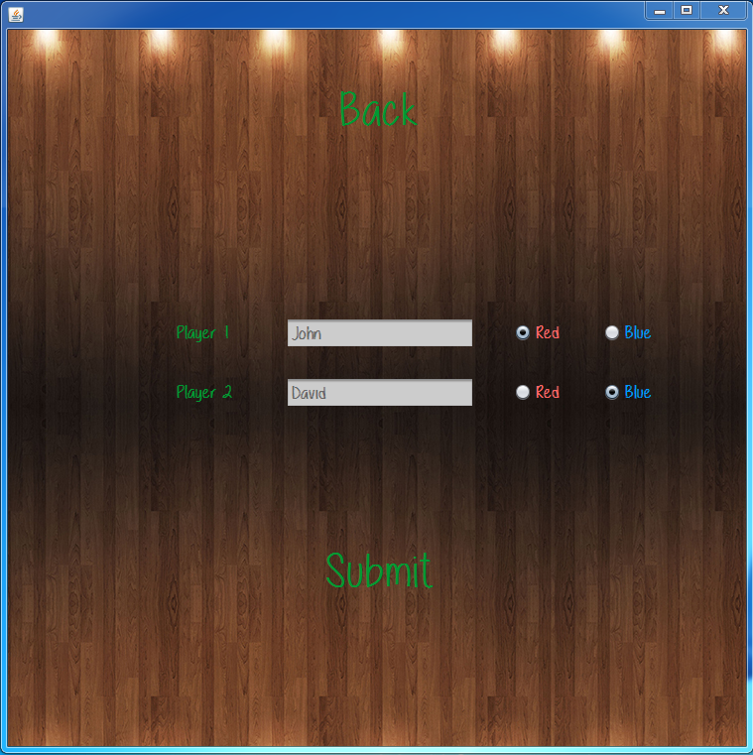  
Overview

* It allows players to enter their names and select the colour for their players.
* Stores the variables in public class ‘pclass.java’ in the ‘classes’ package.

# VS_Player.java

1. import classes.pclass;
2. import javax.swing.JOptionPane;

5. **public** **class** VS_Player extends javax.swing.JFrame {
7. /**
8. * Creates new form VS_Player
9. */
11. **public** VS_Player() {
12. initComponents();
13. }
14. **private** **void** jButton1ActionPerformed(java.awt.event.ActionEvent evt) {
15. **new** Splash().setVisible(**true**);
16. **this**.dispose();
17. }
19. **private** **void** jButton2ActionPerformed(java.awt.event.ActionEvent evt) {
20. String p1 = txtp1.getText();
21. String p2 = txtp2.getText();
22. **if**(redp1.isSelected()){
23. **if**(redp2.isSelected()){
24. JOptionPane.showMessageDialog(null, "Only one red allowed.");
25. Player1BG.clearSelection();
26. Player2BG.clearSelection();
27. }
28. }
29. **else** **if**(redp2.isSelected()){
30. **if**(redp1.isSelected()){
31. JOptionPane.showMessageDialog(null, "Only one red allowed.");
32. Player1BG.clearSelection();
33. Player2BG.clearSelection();
34. }
35. }
36. **if**(bluep1.isSelected()){
37. **if**(bluep2.isSelected()){
38. JOptionPane.showMessageDialog(null,"Only one blue allowed.");
39. Player1BG.clearSelection();
40. Player2BG.clearSelection();
41. }
42. }
43. **else** **if**(bluep2.isSelected()){
44. **if**(bluep1.isSelected()){
45. JOptionPane.showMessageDialog(null,"Only one blue allowed.");
46. Player1BG.clearSelection();
47. Player2BG.clearSelection();
48. }
49. }
51. **if**("".equals(p1) || "".equals(p2)){
52. JOptionPane.showMessageDialog(null, "Please enter names for players.");
53. }

56. **if**(bluep1.isSelected() && redp2.isSelected()){
57. pclass.p1c = "blue";
58. pclass.p2c = "red";
59. }
60. **else** **if**(bluep2.isSelected() && redp1.isSelected()){
61. pclass.p2c = "blue";
62. pclass.p1c = "red";
63. }
64. **else**{
65. JOptionPane.showMessageDialog(null, "Please select player colour.");
66. }
67. pclass.p1 = p1;
68. pclass.p2 = p2;
70. **if**(!"".equals(p1) && !"".equals(p2) && pclass.p1 != "" && pclass.p2 != "" && pclass.p1c != "" && pclass.p2c != ""){
71. **new** Play().setVisible(**true**);
72. **this**.dispose();
73. }
75. }
76. **public** **static** **void** main(String args[]) {
77. java.awt.EventQueue.invokeLater(**new** Runnable() {
79. **public** **void** run() {
80. **new** VS_Player().setVisible(**true**);
81. }
82. });
83. }
84. // Variables declaration - do not modify
85. **private** javax.swing.ButtonGroup Player1BG;
86. **private** javax.swing.ButtonGroup Player2BG;
87. **private** javax.swing.ButtonGroup Player3BG;
88. **private** javax.swing.ButtonGroup Player4BG;
89. **private** javax.swing.ButtonGroup Player5BG;
90. **private** javax.swing.JLabel bg;
91. **private** javax.swing.JRadioButton bluep1;
92. **private** javax.swing.JRadioButton bluep2;
93. **private** javax.swing.JButton jButton1;
94. **private** javax.swing.JButton jButton2;
95. **private** javax.swing.JLabel jLabel2;
96. **private** javax.swing.JLabel jLabel4;
97. **private** javax.swing.JRadioButton redp1;
98. **private** javax.swing.JRadioButton redp2;
99. **private** javax.swing.JTextField txtp1;
100. **private** javax.swing.JTextField txtp2;
101. // End of variables declaration
102. }

# pclass.java

1. package classes;
3. import javax.swing.JOptionPane;


7. **public** **class** pclass {
9. //Data member
10. **public** **static** **int** players,turn;
11. **public** **static** **int** a[] = **new** **int**[] {0,0,0,0,0,0,0};;
12. **public** **static** **int** b[] = **new** **int**[] {0,0,0,0,0,0,0};;
13. **public** **static** **int** c[] = **new** **int**[] {0,0,0,0,0,0,0};;
14. **public** **static** **int** d[] = **new** **int**[] {0,0,0,0,0,0,0};;
15. **public** **static** **int** e[] = **new** **int**[] {0,0,0,0,0,0,0};;
16. **public** **static** **int** f[] = **new** **int**[] {0,0,0,0,0,0,0};;
17. **public** **static** **int** g[] = **new** **int**[] {0,0,0,0,0,0,0};;
18. **public** **static** String p1 = "Player 1";
19. **public** **static** String p2 = "Player 2";
20. **public** **static** String p2c = "";
21. **public** **static** String p1c = "";

# Frame 4: Play.java

# Media:Pictures:project:play11.PNG

Overview

* The final frame in the project where the actual game is played.
* It loads variables from ‘pclass.java’ where the previous frame saved the variables in.

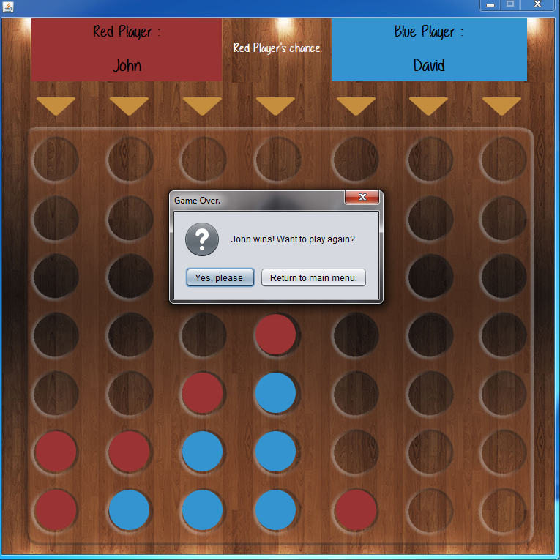

* The game keeps running until the pattern of four coins of same colour horizontally, vertically or diagonally is achieved by either of the player.
* After the pattern is achieved, the popup congratulates winning player and gives option to either play the game again or return to the main menu(Splash.java).

# Play.java

1. import classes.pclass;
2. import javax.swing.JOptionPane;

5. **public** **class** Play extends javax.swing.JFrame {
7. /**
8. * Creates new form Play
9. */

12. **int** checkno=0;
13. String winner;
15. **public** Play() {
16. initComponents();
17. jpWrap.setSize(759,759);
18. jpWrap.setSize(760,760);
19. pclass.turn = 2;
20. lblchance.setText("Red Player's chance.");
21. **if**(pclass.p1c == "red" && pclass.p2c == "blue"){
22. redp.setText(pclass.p1);
23. bluep.setText(pclass.p2);
25. }
26. **else**{
27. redp.setText(pclass.p2);
28. bluep.setText(pclass.p1);
29. }
30. //Resetting Array Values
31. **for**(**int** i=0;i<=6;i++){
32. pclass.a[i]=0;
33. pclass.b[i]=0;
34. pclass.c[i]=0;
35. pclass.d[i]=0;
36. pclass.e[i]=0;
37. pclass.f[i]=0;
38. pclass.g[i]=0;
39. }
41. }
43. **public** **void** patternMatch(){
45. **if**(pclass.turn==2){
46. **if**(pclass.p1c == "red"){
47. winner = pclass.p1;
48. }
49. **else**{
50. winner = pclass.p2;
51. }
52. }
53. **else** **if**(pclass.turn==1){
54. **if**(pclass.p1c == "blue"){
55. winner = pclass.p1;
56. }
57. **else**{
58. winner = pclass.p2;
59. }
60. }
61. Object[] options = {"Yes, please.",
62. "Return to main menu."};
63. **int** n = JOptionPane.showOptionDialog(null,winner+" wins! Want to play again?",
64. "Game Over.",
65. JOptionPane.YES_NO_OPTION,
66. JOptionPane.QUESTION_MESSAGE,
67. null,
68. options,
69. options[0]);
70. **if**(n==JOptionPane.YES_OPTION){
71. **for**(**int** i=0;i<=6;i++){
72. pclass.a[i]=0;
73. pclass.b[i]=0;
74. pclass.c[i]=0;
75. pclass.d[i]=0;
76. pclass.e[i]=0;
77. pclass.f[i]=0;
78. pclass.g[i]=0;
79. }
80. **new** Play().setVisible(**true**);
81. **this**.dispose();
83. }
84. **else** **if**(n==JOptionPane.NO_OPTION){
85. **new** Splash().setVisible(**true**);
86. **this**.dispose();
87. }
88. }
89. **private** **void** cmdGActionPerformed(java.awt.event.ActionEvent evt) {
90. **int** x = 6,pattern=1;
91. **while**(pclass.g[x]!=0){
92. x--;
93. }
94. pclass.g[x] = pclass.turn;
96. **if**(pclass.g[6]==1){
97. g6.setIcon(**new** javax.swing.ImageIcon(getClass().getResource("/images/blue.png")));
98. }
99. **else** **if**(pclass.g[6]==2){
100. g6.setIcon(**new** javax.swing.ImageIcon(getClass().getResource("/images/red.png")));
101. }
103. **if**(pclass.g[5]==1){
104. g5.setIcon(**new** javax.swing.ImageIcon(getClass().getResource("/images/blue.png")));
105. }
106. **else** **if**(pclass.g[5]==2){
107. g5.setIcon(**new** javax.swing.ImageIcon(getClass().getResource("/images/red.png")));
108. }
110. **if**(pclass.g[4]==1){
111. g4.setIcon(**new** javax.swing.ImageIcon(getClass().getResource("/images/blue.png")));
112. }
113. **else** **if**(pclass.g[4]==2){
114. g4.setIcon(**new** javax.swing.ImageIcon(getClass().getResource("/images/red.png")));
115. }
117. **if**(pclass.g[3]==1){
118. g3.setIcon(**new** javax.swing.ImageIcon(getClass().getResource("/images/blue.png")));
119. }
120. **else** **if**(pclass.g[3]==2){
121. g3.setIcon(**new** javax.swing.ImageIcon(getClass().getResource("/images/red.png")));
122. }
124. **if**(pclass.g[2]==1){
125. g2.setIcon(**new** javax.swing.ImageIcon(getClass().getResource("/images/blue.png")));
126. }
127. **else** **if**(pclass.g[2]==2){
128. g2.setIcon(**new** javax.swing.ImageIcon(getClass().getResource("/images/red.png")));
129. }
131. **if**(pclass.g[1]==1){
132. g1.setIcon(**new** javax.swing.ImageIcon(getClass().getResource("/images/blue.png")));
133. }
134. **else** **if**(pclass.g[1]==2){
135. g1.setIcon(**new** javax.swing.ImageIcon(getClass().getResource("/images/red.png")));
136. }
138. **if**(pclass.g[0]==1){
139. g0.setIcon(**new** javax.swing.ImageIcon(getClass().getResource("/images/blue.png")));
140. }
141. **else** **if**(pclass.g[0]==2){
142. g0.setIcon(**new** javax.swing.ImageIcon(getClass().getResource("/images/red.png")));
143. }
145. //Horizontal
146. **if**(pclass.f[x]==pclass.g[x]){
147. **if**(pclass.e[x]==pclass.g[x]){
148. **if**(pclass.d[x]==pclass.g[x]){
149. patternMatch();
150. }
151. }
152. }
154. //
155. //Diagonal
156. //
158. //Towards left
159. **if**(x+1<=6){//Down
160. **if**(pclass.f[x+1]==pclass.turn){
161. pattern++;
162. **if**(x+2<=6){
163. **if**(pclass.e[x+2]==pclass.turn){
164. pattern++;
165. **if**(x+3<=6){
166. **if**(pclass.d[x+3]==pclass.turn){
167. pattern++;
168. }
169. }
170. }
171. }
172. }
173. }
174. **if**(x-1>=0){//Up
175. **if**(pclass.f[x-1]==pclass.turn){
176. pattern++;
177. **if**(x-2>=0){
178. **if**(pclass.e[x-2]==pclass.turn){
179. pattern++;
180. **if**(x-3>=0){
181. **if**(pclass.d[x-3]==pclass.turn){
182. pattern++;
183. }
184. }
185. }
186. }
187. }
188. }
189. **if**(pattern>=4){
190. patternMatch();
191. }
192. **else**{
193. pattern = 1;
194. }
196. //Vertical
197. **if**(x<=3){
198. **for**(**int** i=x+1;i<=6;i++){
199. **if**(pclass.g[i]==pclass.turn){
200. pattern++;
201. }
202. **else** **if**(pclass.g[i]!=pclass.turn){
203. **break**;
204. }
205. }
206. }
207. **if**(pattern>=4){
208. patternMatch();
209. }
210. **else**{
211. pattern = 1;
212. }
214. **if**(pclass.turn == 2){
215. pclass.turn = 1;
216. }
217. **else** **if**(pclass.turn == 1){
218. pclass.turn = 2;
219. }
220. **if**(pclass.g[0] == 1 || pclass.g[0] == 2){
221. cmdG.setEnabled(**false**);
222. }
223. }
225. **private** **void** cmdCActionPerformed(java.awt.event.ActionEvent evt) {
226. **int** x = 6,pattern=1,ltor=1,rtol=1;
227. **while**(pclass.c[x]!=0){
228. x--;
229. }
230. pclass.c[x] = pclass.turn;
232. **if**(pclass.c[6]==1){
233. c6.setIcon(**new** javax.swing.ImageIcon(getClass().getResource("/images/blue.png")));
234. }
235. **else** **if**(pclass.c[6]==2){
236. c6.setIcon(**new** javax.swing.ImageIcon(getClass().getResource("/images/red.png")));
237. }
239. **if**(pclass.c[5]==1){
240. c5.setIcon(**new** javax.swing.ImageIcon(getClass().getResource("/images/blue.png")));
241. }
242. **else** **if**(pclass.c[5]==2){
243. c5.setIcon(**new** javax.swing.ImageIcon(getClass().getResource("/images/red.png")));
244. }
246. **if**(pclass.c[4]==1){
247. c4.setIcon(**new** javax.swing.ImageIcon(getClass().getResource("/images/blue.png")));
248. }
249. **else** **if**(pclass.c[4]==2){
250. c4.setIcon(**new** javax.swing.ImageIcon(getClass().getResource("/images/red.png")));
251. }
253. **if**(pclass.c[3]==1){
254. c3.setIcon(**new** javax.swing.ImageIcon(getClass().getResource("/images/blue.png")));
255. }
256. **else** **if**(pclass.c[3]==2){
257. c3.setIcon(**new** javax.swing.ImageIcon(getClass().getResource("/images/red.png")));
258. }
260. **if**(pclass.c[2]==1){
261. c2.setIcon(**new** javax.swing.ImageIcon(getClass().getResource("/images/blue.png")));
262. }
263. **else** **if**(pclass.c[2]==2){
264. c2.setIcon(**new** javax.swing.ImageIcon(getClass().getResource("/images/red.png")));
265. }
267. **if**(pclass.c[1]==1){
268. c1.setIcon(**new** javax.swing.ImageIcon(getClass().getResource("/images/blue.png")));
269. }
270. **else** **if**(pclass.c[1]==2){
271. c1.setIcon(**new** javax.swing.ImageIcon(getClass().getResource("/images/red.png")));
272. }
274. **if**(pclass.c[0]==1){
275. c0.setIcon(**new** javax.swing.ImageIcon(getClass().getResource("/images/blue.png")));
276. }
277. **else** **if**(pclass.c[0]==2){
278. c0.setIcon(**new** javax.swing.ImageIcon(getClass().getResource("/images/red.png")));
279. }
281. //Vertical
282. **if**(x<=3){
283. **for**(**int** i=x+1;i<=6;i++){
284. **if**(pclass.c[i]==pclass.turn){
285. pattern++;
286. }
287. **else** **if**(pclass.c[i]!=pclass.turn){
288. **break**;
289. }
290. }
291. }
292. **if**(pattern>=4){
293. patternMatch();
294. }
295. **else**{
296. pattern = 1;
297. }
299. //
300. //Horizontal
301. //
303. //Towards left
304. **if**(pclass.b[x]==pclass.turn){
305. pattern++;
306. **if**(pclass.a[x]==pclass.turn){
307. pattern++;
308. }
309. }
310. //Towards right
311. **if**(pclass.d[x]==pclass.turn){
312. pattern++;
313. **if**(pclass.e[x]==pclass.turn){
314. pattern++;
315. **if**(pclass.f[x]==pclass.turn){
316. pattern++;
317. }
318. }
319. }
320. **if**(pattern>=4){
321. patternMatch();
322. }
323. **else**{
324. pattern = 1;
325. }
327. //
328. //Diagonal
329. //
331. //Towards right
332. **if**(x+1<=6){//Down
333. **if**(pclass.d[x+1]==pclass.turn){
334. ltor++;
335. **if**(x+2<=6){
336. **if**(pclass.e[x+2]==pclass.turn){
337. ltor++;
338. **if**(x+3<=6){
339. **if**(pclass.f[x+3]==pclass.turn){
340. ltor++;
341. }
342. }
343. }
344. }
345. }
346. }
347. **if**(x-1>=0){//Up
348. **if**(pclass.d[x-1]==pclass.turn){
349. rtol++;
350. **if**(x-2>=0){
351. **if**(pclass.e[x-2]==pclass.turn){
352. rtol++;
353. **if**(x-3>=0){
354. **if**(pclass.f[x-3]==pclass.turn){
355. rtol++;
356. }
357. }
358. }
359. }
360. }
361. }
362. //Towards left
363. **if**(x+1<=6){//Down
364. **if**(pclass.b[x+1]==pclass.turn){
365. rtol++;
366. **if**(x+2<=6){
367. **if**(pclass.a[x+2]==pclass.turn){
368. rtol++;
369. }
370. }
371. }
372. }
373. **if**(x-1>=0){//Up
374. **if**(pclass.b[x-1]==pclass.turn){
375. ltor++;
376. **if**(x-2>=0){
377. **if**(pclass.a[x-2]==pclass.turn){
378. ltor++;
379. }
380. }
381. }
382. }
383. **if**(ltor>=4 || rtol>=4){
384. patternMatch();
385. }
386. **else**{
387. pattern = 1;
388. ltor = 1;
389. rtol = 1;
390. }
392. **if**(pclass.turn == 1){
393. pclass.turn = 2;
394. }
395. **else** **if**(pclass.turn == 2){
396. pclass.turn = 1;
397. }
398. **if**(pclass.c[0] == 1 || pclass.c[0] == 2){
399. cmdC.setEnabled(**false**);
400. }
402. }
404. **private** **void** cmdFActionPerformed(java.awt.event.ActionEvent evt) {
405. **int** x = 6,pattern=1,ltor=1,rtol=1;
406. **while**(pclass.f[x]!=0){
407. x--;
408. }
409. pclass.f[x] = pclass.turn;
411. **if**(pclass.f[6]==1){
412. f6.setIcon(**new** javax.swing.ImageIcon(getClass().getResource("/images/blue.png")));
413. }
414. **else** **if**(pclass.f[6]==2){
415. f6.setIcon(**new** javax.swing.ImageIcon(getClass().getResource("/images/red.png")));
416. }
418. **if**(pclass.f[5]==1){
419. f5.setIcon(**new** javax.swing.ImageIcon(getClass().getResource("/images/blue.png")));
420. }
421. **else** **if**(pclass.f[5]==2){
422. f5.setIcon(**new** javax.swing.ImageIcon(getClass().getResource("/images/red.png")));
423. }
425. **if**(pclass.f[4]==1){
426. f4.setIcon(**new** javax.swing.ImageIcon(getClass().getResource("/images/blue.png")));
427. }
428. **else** **if**(pclass.f[4]==2){
429. f4.setIcon(**new** javax.swing.ImageIcon(getClass().getResource("/images/red.png")));
430. }
432. **if**(pclass.f[3]==1){
433. f3.setIcon(**new** javax.swing.ImageIcon(getClass().getResource("/images/blue.png")));
434. }
435. **else** **if**(pclass.f[3]==2){
436. f3.setIcon(**new** javax.swing.ImageIcon(getClass().getResource("/images/red.png")));
437. }
439. **if**(pclass.f[2]==1){
440. f2.setIcon(**new** javax.swing.ImageIcon(getClass().getResource("/images/blue.png")));
441. }
442. **else** **if**(pclass.f[2]==2){
443. f2.setIcon(**new** javax.swing.ImageIcon(getClass().getResource("/images/red.png")));
444. }
446. **if**(pclass.f[1]==1){
447. f1.setIcon(**new** javax.swing.ImageIcon(getClass().getResource("/images/blue.png")));
448. }
449. **else** **if**(pclass.f[1]==2){
450. f1.setIcon(**new** javax.swing.ImageIcon(getClass().getResource("/images/red.png")));
451. }
453. **if**(pclass.f[0]==1){
454. f0.setIcon(**new** javax.swing.ImageIcon(getClass().getResource("/images/blue.png")));
455. }
456. **else** **if**(pclass.f[0]==2){
457. f0.setIcon(**new** javax.swing.ImageIcon(getClass().getResource("/images/red.png")));
458. }
460. //Vertical
461. **if**(x<=3){
462. **for**(**int** i=x+1;i<=6;i++){
463. **if**(pclass.f[i]==pclass.turn){
464. pattern++;
465. }
466. **else** **if**(pclass.f[i]!=pclass.turn){
467. **break**;
468. }
469. }
470. }
471. **if**(pattern>=4){
472. patternMatch();
473. }
474. **else**{
475. pattern = 1;
476. }
478. //
479. //Horizontal
480. //
482. //Towards left
483. **if**(pclass.e[x]==pclass.turn){
484. pattern++;
485. **if**(pclass.d[x]==pclass.turn){
486. pattern++;
487. **if**(pclass.c[x]==pclass.turn){
488. pattern++;
489. }
490. }
491. }
492. //Towards right
493. **if**(pclass.g[x]==pclass.turn){
494. pattern++;
495. }
496. **if**(pattern>=4){
497. patternMatch();
498. }
499. **else**{
500. pattern = 1;
501. }
503. //
504. //Diagonal
505. //
507. //Towards right
508. **if**(x+1<=6){//Down
509. **if**(pclass.g[x+1]==pclass.turn){
510. ltor++;
511. }
512. }
513. **if**(x-1>=0){//Up
514. **if**(pclass.g[x-1]==pclass.turn){
515. rtol++;
516. }
517. }
518. //Towards left
519. **if**(x+1<=6){//Down
520. **if**(pclass.e[x+1]==pclass.turn){
521. rtol++;
522. **if**(x+2<=6){
523. **if**(pclass.d[x+2]==pclass.turn){
524. rtol++;
525. **if**(x+3<=6){
526. **if**(pclass.c[x+3]==pclass.turn){
527. rtol++;
528. }
529. }
530. }
531. }
532. }
533. }
534. **if**(x-1>=0){//Up
535. **if**(pclass.e[x-1]==pclass.turn){
536. ltor++;
537. **if**(x-2>=0){
538. **if**(pclass.d[x-2]==pclass.turn){
539. ltor++;
540. **if**(x-3>=0){
541. **if**(pclass.c[x-3]==pclass.turn){
542. ltor++;
543. }
544. }
545. }
546. }
547. }
548. }
549. **if**(ltor>=4 || rtol>=4){
550. patternMatch();
551. }
552. **else**{
553. pattern = 1;
554. ltor = 1;
555. rtol = 1;
556. }
558. **if**(pclass.turn == 1){
559. pclass.turn = 2;
560. }
561. **else** **if**(pclass.turn == 2){
562. pclass.turn = 1;
563. }
564. **if**(pclass.f[0] == 1 || pclass.f[0] == 2){
565. cmdF.setEnabled(**false**);
566. }
567. }
569. **private** **void** cmdEActionPerformed(java.awt.event.ActionEvent evt) {
570. **int** x = 6,pattern=1,ltor=1,rtol=1;
571. **while**(pclass.e[x]!=0){
572. x--;
573. }
574. pclass.e[x] = pclass.turn;
576. **if**(pclass.e[6]==1){
577. e6.setIcon(**new** javax.swing.ImageIcon(getClass().getResource("/images/blue.png")));
578. }
579. **else** **if**(pclass.e[6]==2){
580. e6.setIcon(**new** javax.swing.ImageIcon(getClass().getResource("/images/red.png")));
581. }
583. **if**(pclass.e[5]==1){
584. e5.setIcon(**new** javax.swing.ImageIcon(getClass().getResource("/images/blue.png")));
585. }
586. **else** **if**(pclass.e[5]==2){
587. e5.setIcon(**new** javax.swing.ImageIcon(getClass().getResource("/images/red.png")));
588. }
590. **if**(pclass.e[4]==1){
591. e4.setIcon(**new** javax.swing.ImageIcon(getClass().getResource("/images/blue.png")));
592. }
593. **else** **if**(pclass.e[4]==2){
594. e4.setIcon(**new** javax.swing.ImageIcon(getClass().getResource("/images/red.png")));
595. }
597. **if**(pclass.e[3]==1){
598. e3.setIcon(**new** javax.swing.ImageIcon(getClass().getResource("/images/blue.png")));
599. }
600. **else** **if**(pclass.e[3]==2){
601. e3.setIcon(**new** javax.swing.ImageIcon(getClass().getResource("/images/red.png")));
602. }
604. **if**(pclass.e[2]==1){
605. e2.setIcon(**new** javax.swing.ImageIcon(getClass().getResource("/images/blue.png")));
606. }
607. **else** **if**(pclass.e[2]==2){
608. e2.setIcon(**new** javax.swing.ImageIcon(getClass().getResource("/images/red.png")));
609. }
611. **if**(pclass.e[1]==1){
612. e1.setIcon(**new** javax.swing.ImageIcon(getClass().getResource("/images/blue.png")));
613. }
614. **else** **if**(pclass.e[1]==2){
615. e1.setIcon(**new** javax.swing.ImageIcon(getClass().getResource("/images/red.png")));
616. }
618. **if**(pclass.e[0]==1){
619. e0.setIcon(**new** javax.swing.ImageIcon(getClass().getResource("/images/blue.png")));
620. }
621. **else** **if**(pclass.e[0]==2){
622. e0.setIcon(**new** javax.swing.ImageIcon(getClass().getResource("/images/red.png")));
623. }
625. //Vertical
626. **if**(x<=3){
627. **for**(**int** i=x+1;i<=6;i++){
628. **if**(pclass.e[i]==pclass.turn){
629. pattern++;
630. }
631. **else** **if**(pclass.e[i]!=pclass.turn){
632. **break**;
633. }
634. }
635. }
636. **if**(pattern>=4){
637. patternMatch();
638. }
639. **else**{
640. pattern = 1;
641. }
642. //
643. //Horizontal
644. //
646. //Towards left
647. **if**(pclass.d[x]==pclass.turn){
648. pattern++;
649. **if**(pclass.c[x]==pclass.turn){
650. pattern++;
651. **if**(pclass.b[x]==pclass.turn){
652. pattern++;
653. }
654. }
655. }
656. //Towards right
657. **if**(pclass.f[x]==pclass.turn){
658. pattern++;
659. **if**(pclass.g[x]==pclass.turn){
660. pattern++;
661. }
662. }
663. **if**(pattern>=4){
664. patternMatch();
665. }
666. **else**{
667. pattern = 1;
668. }
670. //
671. //Diagonal
672. //
674. //Towards right
675. **if**(x+1<=6){//Down
676. **if**(pclass.f[x+1]==pclass.turn){
677. ltor++;
678. **if**(x+2<=6){
679. **if**(pclass.g[x+2]==pclass.turn){
680. ltor++;
681. }
682. }
683. }
684. }
685. **if**(x-1>=0){//Up
686. **if**(pclass.f[x-1]==pclass.turn){
687. rtol++;
688. **if**(x-2>=0){
689. **if**(pclass.g[x-2]==pclass.turn){
690. rtol++;
691. }
692. }
693. }
694. }
695. //Towards left
696. **if**(x+1<=6){//Down
697. **if**(pclass.d[x+1]==pclass.turn){
698. rtol++;
699. **if**(x+2<=6){
700. **if**(pclass.c[x+2]==pclass.turn){
701. rtol++;
702. **if**(x+3<=6){
703. **if**(pclass.b[x+3]==pclass.turn){
704. rtol++;
705. }
706. }
707. }
708. }
709. }
710. }
711. **if**(x-1>=0){//Up
712. **if**(pclass.d[x-1]==pclass.turn){
713. ltor++;
714. **if**(x-2>=0){
715. **if**(pclass.c[x-2]==pclass.turn){
716. ltor++;
717. **if**(x-3>=0){
718. **if**(pclass.b[x-3]==pclass.turn){
719. ltor++;
720. }
721. }
722. }
723. }
724. }
725. }
726. **if**(ltor>=4 || rtol>=4){
727. patternMatch();
728. }
729. **else**{
730. pattern = 1;
731. ltor = 1;
732. rtol = 1;
733. }
735. **if**(pclass.turn == 1){
736. pclass.turn = 2;
737. }
738. **else** **if**(pclass.turn == 2){
739. pclass.turn = 1;
740. }
741. **if**(pclass.e[0] == 1 || pclass.e[0] == 2){
742. cmdE.setEnabled(**false**);
743. }
744. }
746. **private** **void** cmdDActionPerformed(java.awt.event.ActionEvent evt) {
747. **int** x = 6,pattern=1,ltor=1,rtol=1;
748. **while**(pclass.d[x]!=0){
749. x--;
750. }
751. pclass.d[x] = pclass.turn;
753. **if**(pclass.d[6]==1){
754. d6.setIcon(**new** javax.swing.ImageIcon(getClass().getResource("/images/blue.png")));
755. }
756. **else** **if**(pclass.d[6]==2){
757. d6.setIcon(**new** javax.swing.ImageIcon(getClass().getResource("/images/red.png")));
758. }
760. **if**(pclass.d[5]==1){
761. d5.setIcon(**new** javax.swing.ImageIcon(getClass().getResource("/images/blue.png")));
762. }
763. **else** **if**(pclass.d[5]==2){
764. d5.setIcon(**new** javax.swing.ImageIcon(getClass().getResource("/images/red.png")));
765. }
767. **if**(pclass.d[4]==1){
768. d4.setIcon(**new** javax.swing.ImageIcon(getClass().getResource("/images/blue.png")));
769. }
770. **else** **if**(pclass.d[4]==2){
771. d4.setIcon(**new** javax.swing.ImageIcon(getClass().getResource("/images/red.png")));
772. }
774. **if**(pclass.d[3]==1){
775. d3.setIcon(**new** javax.swing.ImageIcon(getClass().getResource("/images/blue.png")));
776. }
777. **else** **if**(pclass.d[3]==2){
778. d3.setIcon(**new** javax.swing.ImageIcon(getClass().getResource("/images/red.png")));
779. }
781. **if**(pclass.d[2]==1){
782. d2.setIcon(**new** javax.swing.ImageIcon(getClass().getResource("/images/blue.png")));
783. }
784. **else** **if**(pclass.d[2]==2){
785. d2.setIcon(**new** javax.swing.ImageIcon(getClass().getResource("/images/red.png")));
786. }
788. **if**(pclass.d[1]==1){
789. d1.setIcon(**new** javax.swing.ImageIcon(getClass().getResource("/images/blue.png")));
790. }
791. **else** **if**(pclass.d[1]==2){
792. d1.setIcon(**new** javax.swing.ImageIcon(getClass().getResource("/images/red.png")));
793. }
795. **if**(pclass.d[0]==1){
796. d0.setIcon(**new** javax.swing.ImageIcon(getClass().getResource("/images/blue.png")));
797. }
798. **else** **if**(pclass.d[0]==2){
799. d0.setIcon(**new** javax.swing.ImageIcon(getClass().getResource("/images/red.png")));
800. }
802. //Vertical
803. **if**(x<=3){
804. **for**(**int** i=x+1;i<=6;i++){
805. **if**(pclass.d[i]==pclass.turn){
806. pattern++;
807. }
808. **else** **if**(pclass.d[i]!=pclass.turn){
809. **break**;
810. }
811. }
812. }
813. **if**(pattern>=4){
814. patternMatch();
815. }
816. **else**
817. pattern = 1;
819. //
820. //Horizontal
821. //
823. //Towards left
824. **if**(pclass.c[x]==pclass.turn){
825. pattern++;
826. **if**(pclass.b[x]==pclass.turn){
827. pattern++;
828. **if**(pclass.a[x]==pclass.turn){
829. pattern++;
830. }
831. }
832. }
833. //Towards right
834. **if**(pclass.e[x]==pclass.turn){
835. pattern++;
836. **if**(pclass.f[x]==pclass.turn){
837. pattern++;
838. **if**(pclass.g[x]==pclass.turn){
839. pattern++;
840. }
841. }
842. }
843. **if**(pattern>=4){
844. patternMatch();
845. }
846. **else**{
847. pattern = 1;
848. }
850. //
851. //Diagonal
852. //
854. //Towards right
855. **if**(x+1<=6){//Down
856. **if**(pclass.e[x+1]==pclass.turn){
857. ltor++;
858. **if**(x+2<=6){
859. **if**(pclass.f[x+2]==pclass.turn){
860. ltor++;
861. **if**(x+3<=6){
862. **if**(pclass.g[x+3]==pclass.turn){
863. ltor++;
864. }
865. }
866. }
867. }
868. }
869. }
870. **if**(x-1>=0){//Up
871. **if**(pclass.e[x-1]==pclass.turn){
872. rtol++;
873. **if**(x-2>=0){
874. **if**(pclass.f[x-2]==pclass.turn){
875. rtol++;
876. **if**(x-3>=0){
877. **if**(pclass.g[x-3]==pclass.turn){
878. rtol++;
879. }
880. }
881. }
882. }
883. }
884. }
885. //Towards left
886. **if**(x+1<=6){//Down
887. **if**(pclass.c[x+1]==pclass.turn){
888. rtol++;
889. **if**(x+2<=6){
890. **if**(pclass.b[x+2]==pclass.turn){
891. rtol++;
892. **if**(x+3<=6){
893. **if**(pclass.a[x+3]==pclass.turn){
894. rtol++;
895. }
896. }
897. }
898. }
899. }
900. }
901. **if**(x-1>=0){//Up
902. **if**(pclass.c[x-1]==pclass.turn){
903. ltor++;
904. **if**(x-2>=0){
905. **if**(pclass.b[x-2]==pclass.turn){
906. ltor++;
907. **if**(x-3>=0){
908. **if**(pclass.a[x-3]==pclass.turn){
909. ltor++;
910. }
911. }
912. }
913. }
914. }
915. }
916. **if**(ltor>=4 || rtol>=4){
917. patternMatch();
918. }
919. **else**{
920. pattern = 1;
921. ltor = 1;
922. rtol = 1;
923. }
925. **if**(pclass.turn == 1){
926. pclass.turn = 2;
927. }
928. **else** **if**(pclass.turn == 2){
929. pclass.turn = 1;
930. }
931. **if**(pclass.d[0] == 1 || pclass.d[0] == 2){
932. cmdD.setEnabled(**false**);
933. }
934. }
936. **private** **void** cmdBActionPerformed(java.awt.event.ActionEvent evt) {
938. **int** x = 6,pattern=1,ltor=1,rtol=1;
939. **while**(pclass.b[x]!=0){
940. x--;
941. }
942. pclass.b[x] = pclass.turn;
944. **if**(pclass.b[6]==1){
945. b6.setIcon(**new** javax.swing.ImageIcon(getClass().getResource("/images/blue.png")));
946. }
947. **else** **if**(pclass.b[6]==2){
948. b6.setIcon(**new** javax.swing.ImageIcon(getClass().getResource("/images/red.png")));
949. }
951. **if**(pclass.b[5]==1){
952. b5.setIcon(**new** javax.swing.ImageIcon(getClass().getResource("/images/blue.png")));
953. }
954. **else** **if**(pclass.b[5]==2){
955. b5.setIcon(**new** javax.swing.ImageIcon(getClass().getResource("/images/red.png")));
956. }
958. **if**(pclass.b[4]==1){
959. b4.setIcon(**new** javax.swing.ImageIcon(getClass().getResource("/images/blue.png")));
960. }
961. **else** **if**(pclass.b[4]==2){
962. b4.setIcon(**new** javax.swing.ImageIcon(getClass().getResource("/images/red.png")));
963. }
965. **if**(pclass.b[3]==1){
966. b3.setIcon(**new** javax.swing.ImageIcon(getClass().getResource("/images/blue.png")));
967. }
968. **else** **if**(pclass.b[3]==2){
969. b3.setIcon(**new** javax.swing.ImageIcon(getClass().getResource("/images/red.png")));
970. }
972. **if**(pclass.b[2]==1){
973. b2.setIcon(**new** javax.swing.ImageIcon(getClass().getResource("/images/blue.png")));
974. }
975. **else** **if**(pclass.b[2]==2){
976. b2.setIcon(**new** javax.swing.ImageIcon(getClass().getResource("/images/red.png")));
977. }
979. **if**(pclass.b[1]==1){
980. b1.setIcon(**new** javax.swing.ImageIcon(getClass().getResource("/images/blue.png")));
981. }
982. **else** **if**(pclass.b[1]==2){
983. b1.setIcon(**new** javax.swing.ImageIcon(getClass().getResource("/images/red.png")));
984. }
986. **if**(pclass.b[0]==1){
987. b0.setIcon(**new** javax.swing.ImageIcon(getClass().getResource("/images/blue.png")));
988. }
989. **else** **if**(pclass.b[0]==2){
990. b0.setIcon(**new** javax.swing.ImageIcon(getClass().getResource("/images/red.png")));
991. }
993. //Vertical
994. **if**(x<=3){
995. **for**(**int** i=x+1;i<=6;i++){
996. **if**(pclass.b[i]==pclass.turn){
997. pattern++;
998. }
999. **else** **if**(pclass.b[i]!=pclass.turn){
1000. **break**;
1001. }
1002. }
1003. }
1004. **if**(pattern>=4){
1005. patternMatch();
1006. }
1007. **else**{
1008. pattern = 1;
1009. }
1010. //
1011. //Horizontal
1012. //
1014. //Towards left
1015. **if**(pclass.a[x]==pclass.turn){
1016. pattern++;
1017. }
1018. //Towards right
1019. **if**(pclass.c[x]==pclass.turn){
1020. pattern++;
1021. **if**(pclass.d[x]==pclass.turn){
1022. pattern++;
1023. **if**(pclass.e[x]==pclass.turn){
1024. pattern++;
1025. }
1026. }
1027. }
1028. **if**(pattern>=4){
1029. patternMatch();
1030. }
1031. **else**{
1032. pattern = 1;
1033. }
1035. //
1036. //Diagonal
1037. //
1039. //Towards right
1040. **if**(x+1<=6){//Down
1041. **if**(pclass.c[x+1]==pclass.turn){
1042. ltor++;
1043. **if**(x+2<=6){
1044. **if**(pclass.d[x+2]==pclass.turn){
1045. ltor++;
1046. **if**(x+3<=6){
1047. **if**(pclass.e[x+3]==pclass.turn){
1048. ltor++;
1049. }
1050. }
1051. }
1052. }
1053. }
1054. }
1055. **if**(x-1>=0){//Up
1056. **if**(pclass.c[x-1]==pclass.turn){
1057. rtol++;
1058. **if**(x-2>=0){
1059. **if**(pclass.d[x-2]==pclass.turn){
1060. rtol++;
1061. **if**(x-3>=0){
1062. **if**(pclass.e[x-3]==pclass.turn){
1063. rtol++;
1064. }
1065. }
1066. }
1067. }
1068. }
1069. }
1070. //Towards left
1071. **if**(x+1<=6){//Down
1072. **if**(pclass.a[x+1]==pclass.turn){
1073. rtol++;
1074. }
1075. }
1076. **if**(x-1>=0){//Up
1077. **if**(pclass.a[x-1]==pclass.turn){
1078. ltor++;
1079. }
1080. }
1081. **if**(ltor>=4 || rtol>=4){
1082. patternMatch();
1083. }
1084. **else**{
1085. pattern = 1;
1086. ltor = 1;
1087. rtol = 1;
1088. }
1090. **if**(pclass.turn == 1){
1091. pclass.turn = 2;
1092. }
1093. **else** **if**(pclass.turn == 2){
1094. pclass.turn = 1;
1095. }
1096. **if**(pclass.b[0] == 1 || pclass.b[0] == 2){
1097. cmdB.setEnabled(**false**);
1098. }
1099. }
1101. **private** **void** cmdAActionPerformed(java.awt.event.ActionEvent evt) {
1102. **int** x = 6,pattern=1;
1103. **while**(pclass.a[x]!=0){
1104. x--;
1105. }
1106. pclass.a[x] = pclass.turn;
1108. **if**(pclass.a[6]==1){
1109. a6.setIcon(**new** javax.swing.ImageIcon(getClass().getResource("/images/blue.png")));
1110. }
1111. **else** **if**(pclass.a[6]==2){
1112. a6.setIcon(**new** javax.swing.ImageIcon(getClass().getResource("/images/red.png")));
1113. }
1115. **if**(pclass.a[5]==1){
1116. a5.setIcon(**new** javax.swing.ImageIcon(getClass().getResource("/images/blue.png")));
1117. }
1118. **else** **if**(pclass.a[5]==2){
1119. a5.setIcon(**new** javax.swing.ImageIcon(getClass().getResource("/images/red.png")));
1120. }
1122. **if**(pclass.a[4]==1){
1123. a4.setIcon(**new** javax.swing.ImageIcon(getClass().getResource("/images/blue.png")));
1124. }
1125. **else** **if**(pclass.a[4]==2){
1126. a4.setIcon(**new** javax.swing.ImageIcon(getClass().getResource("/images/red.png")));
1127. }
1129. **if**(pclass.a[3]==1){
1130. a3.setIcon(**new** javax.swing.ImageIcon(getClass().getResource("/images/blue.png")));
1131. }
1132. **else** **if**(pclass.a[3]==2){
1133. a3.setIcon(**new** javax.swing.ImageIcon(getClass().getResource("/images/red.png")));
1134. }
1136. **if**(pclass.a[2]==1){
1137. a2.setIcon(**new** javax.swing.ImageIcon(getClass().getResource("/images/blue.png")));
1138. }
1139. **else** **if**(pclass.a[2]==2){
1140. a2.setIcon(**new** javax.swing.ImageIcon(getClass().getResource("/images/red.png")));
1141. }
1143. **if**(pclass.a[1]==1){
1144. a1.setIcon(**new** javax.swing.ImageIcon(getClass().getResource("/images/blue.png")));
1145. }
1146. **else** **if**(pclass.a[1]==2){
1147. a1.setIcon(**new** javax.swing.ImageIcon(getClass().getResource("/images/red.png")));
1148. }
1150. **if**(pclass.a[0]==1){
1151. a0.setIcon(**new** javax.swing.ImageIcon(getClass().getResource("/images/blue.png")));
1152. }
1153. **else** **if**(pclass.a[0]==2){
1154. a0.setIcon(**new** javax.swing.ImageIcon(getClass().getResource("/images/red.png")));
1155. }
1157. //Horizontal
1158. **if**(pclass.b[x]==pclass.turn){
1159. **if**(pclass.c[x]==pclass.turn){
1160. **if**(pclass.d[x]==pclass.turn){
1161. patternMatch();
1162. }
1163. }
1164. }
1166. //
1167. //Diagonal
1168. //
1170. //Towards right
1171. **if**(x+1<=6){//Down
1172. **if**(pclass.b[x+1]==pclass.turn){
1173. pattern++;
1174. **if**(x+2<=6){
1175. **if**(pclass.c[x+2]==pclass.turn){
1176. pattern++;
1177. **if**(x+3<=6){
1178. **if**(pclass.d[x+3]==pclass.turn){
1179. pattern++;
1180. }
1181. }
1182. }
1183. }
1184. }
1185. }
1186. **if**(x-1>=0){//Up
1187. **if**(pclass.b[x-1]==pclass.turn){
1188. pattern++;
1189. **if**(x-2>=0){
1190. **if**(pclass.c[x-2]==pclass.turn){
1191. pattern++;
1192. **if**(x-3>=0){
1193. **if**(pclass.d[x-3]==pclass.turn){
1194. pattern++;
1195. }
1196. }
1197. }
1198. }
1199. }
1200. }
1201. **if**(pattern>=4){
1202. patternMatch();
1203. }
1204. **else**{
1205. pattern = 1;
1206. }
1208. //Vertical
1209. **if**(x<=3){
1210. **for**(**int** i=x+1;i<=6;i++){
1211. **if**(pclass.a[i]==pclass.turn){
1212. pattern++;
1213. }
1214. **else** **if**(pclass.a[i]!=pclass.turn){
1215. **break**;
1216. }
1217. }
1218. }
1219. **if**(pattern>=4){
1220. patternMatch();
1221. }
1222. **else**{
1223. pattern = 1;
1224. }
1226. **if**(pclass.turn == 1){
1227. pclass.turn = 2;
1228. }
1229. **else** **if**(pclass.turn == 2){
1230. pclass.turn = 1;
1231. }
1232. **if**(pclass.a[0] == 1 || pclass.a[0] == 2){
1233. cmdA.setEnabled(**false**);
1234. }
1236. }
1238. **private** **void** drop(java.awt.event.ActionEvent evt) {
1239. **if**(pclass.turn==2){
1240. lblchance.setText("Red Player's chance.");
1241. }
1242. **else** **if**(pclass.turn==1){
1243. lblchance.setText("Blue Player's chance.");
1244. }
1245. }

1248. **public** **static** **void** main(String args[]) {
1249. /* Create and display the form */
1250. java.awt.EventQueue.invokeLater(**new** Runnable() {
1251. **public** **void** run() {
1252. **new** Play().setVisible(**true**);
1253. }
1254. });
1255. }
1257. // Variables declaration - do not modify
1258. **private** javax.swing.JButton a0;
1259. **private** javax.swing.JButton a1;
1260. **private** javax.swing.JButton a2;
1261. **private** javax.swing.JButton a3;
1262. **private** javax.swing.JButton a4;
1263. **private** javax.swing.JButton a5;
1264. **private** javax.swing.JButton a6;
1265. **private** javax.swing.JButton b0;
1266. **private** javax.swing.JButton b1;
1267. **private** javax.swing.JButton b2;
1268. **private** javax.swing.JButton b3;
1269. **private** javax.swing.JButton b4;
1270. **private** javax.swing.JButton b5;
1271. **private** javax.swing.JButton b6;
1272. **private** javax.swing.ButtonGroup bgCoinDropper;
1273. **private** javax.swing.JLabel bluep;
1274. **private** javax.swing.JButton c0;
1275. **private** javax.swing.JButton c1;
1276. **private** javax.swing.JButton c2;
1277. **private** javax.swing.JButton c3;
1278. **private** javax.swing.JButton c4;
1279. **private** javax.swing.JButton c5;
1280. **private** javax.swing.JButton c6;
1281. **private** javax.swing.JButton cmdA;
1282. **private** javax.swing.JButton cmdB;
1283. **private** javax.swing.JButton cmdC;
1284. **private** javax.swing.JButton cmdD;
1285. **private** javax.swing.JButton cmdE;
1286. **private** javax.swing.JButton cmdF;
1287. **private** javax.swing.JButton cmdG;
1288. **private** javax.swing.JButton d0;
1289. **private** javax.swing.JButton d1;
1290. **private** javax.swing.JButton d2;
1291. **private** javax.swing.JButton d3;
1292. **private** javax.swing.JButton d4;
1293. **private** javax.swing.JButton d5;
1294. **private** javax.swing.JButton d6;
1295. **private** javax.swing.JButton e0;
1296. **private** javax.swing.JButton e1;
1297. **private** javax.swing.JButton e2;
1298. **private** javax.swing.JButton e3;
1299. **private** javax.swing.JButton e4;
1300. **private** javax.swing.JButton e5;
1301. **private** javax.swing.JButton e6;
1302. **private** javax.swing.JButton f0;
1303. **private** javax.swing.JButton f1;
1304. **private** javax.swing.JButton f2;
1305. **private** javax.swing.JButton f3;
1306. **private** javax.swing.JButton f4;
1307. **private** javax.swing.JButton f5;
1308. **private** javax.swing.JButton f6;
1309. **private** javax.swing.JButton g0;
1310. **private** javax.swing.JButton g1;
1311. **private** javax.swing.JButton g2;
1312. **private** javax.swing.JButton g3;
1313. **private** javax.swing.JButton g4;
1314. **private** javax.swing.JButton g5;
1315. **private** javax.swing.JButton g6;
1316. **private** javax.swing.JPanel jpBlue;
1317. **private** javax.swing.JPanel jpRed;
1318. **private** javax.swing.JPanel jpWrap;
1319. **private** javax.swing.JLabel lblBackground;
1320. **private** javax.swing.JLabel lblbluep;
1321. **private** javax.swing.JLabel lblchance;
1322. **private** javax.swing.JLabel lblredp;
1323. **private** javax.swing.JLabel redp;
1324. // End of variables declaration
1325. }